Subsidy Savings, Higher Revenue and Borrowing
How the Money is Spent

Prepared by the Federal Ministry of Finance - August 2026

How the resources were generated
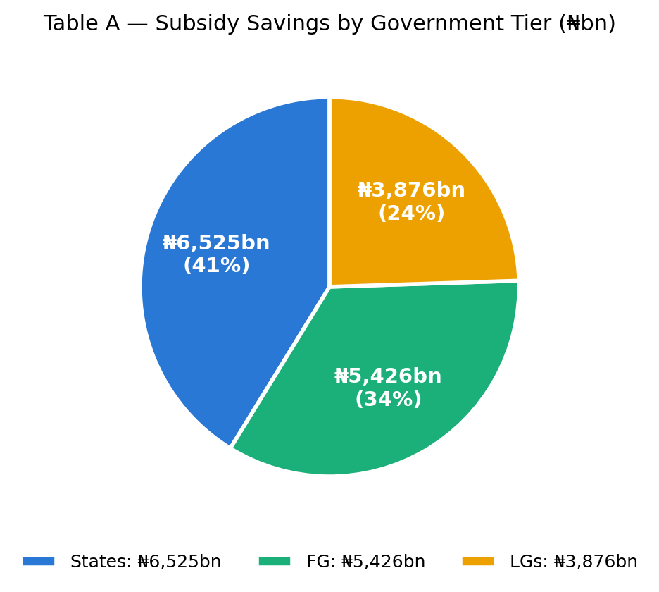
Government | ₦ Billion
FG | 5,426.07
States | 6,524.76
LGs | 3,876.20
TOTAL | 15,827.03
Relative share of subsidy savings by each tier of government in proportion to their FAAC allocations. States retained the largest effective share of 41%, FG 34% and LGs 24%.

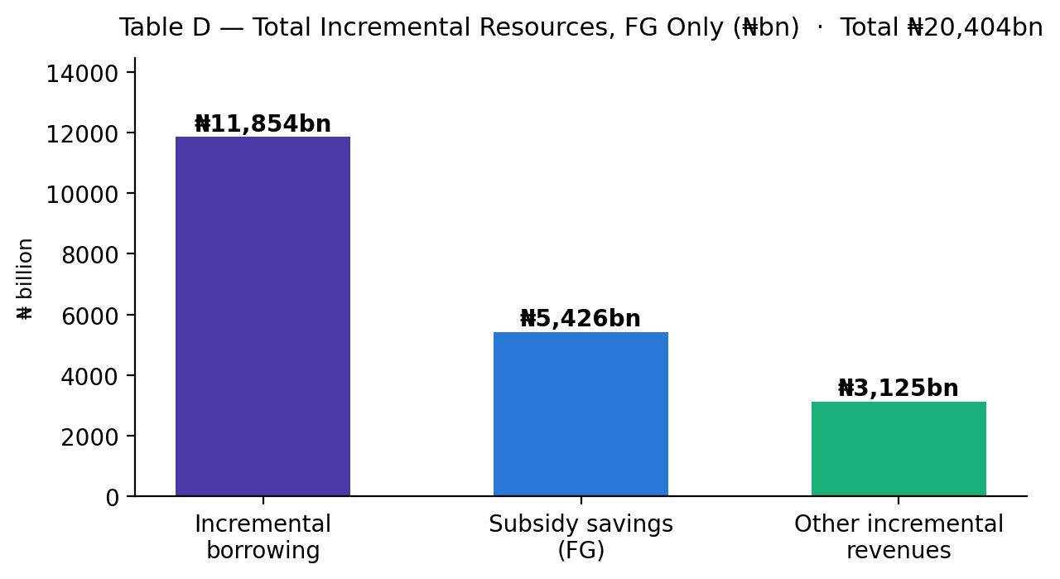
Description | ₦ Billion
Subsidy savings (FG) | 5,426.07
Other incremental revenues | 3,124.51
Incremental borrowing | 11,853.54
TOTAL | 20,404.12
Other incremental revenues is chiefly government-owned entities' remittances.

How the Money is Spent
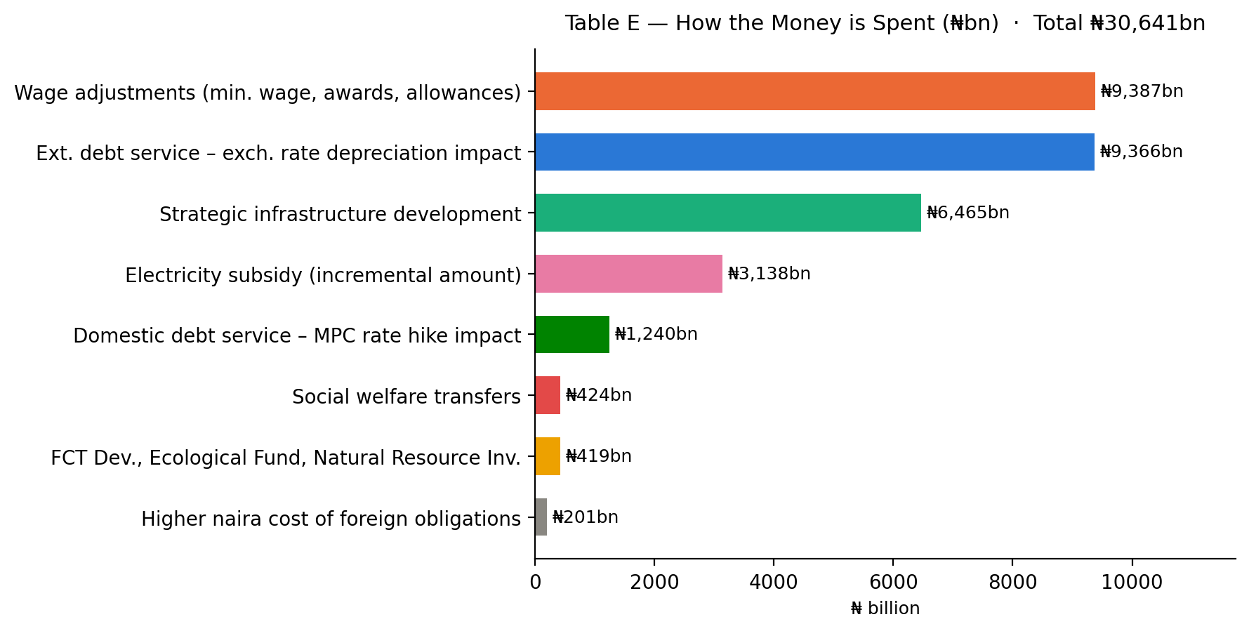
Description | ₦ Billion
Wage adjustments (min. wage increase, wage awards, allowances) | 9,386.90
Ext. debt service – impact of exch. rate depreciation | 9,365.71
Strategic infrastructure development | 6,465.39
Electricity subsidy (incremental amount) | 3,138.15
Domestic debt service – impact of MPC rate hike | 1,240.24
Social welfare transfers | 423.80
FCT Development, Ecological Fund, Natural Resource Inv. etc. | 419.10
Higher naira cost of foreign obligations | 201.26
TOTAL INCREMENTAL EXPENSES | 30,640.54
Wage adjustments alone (N9.4 Trillion) accounted for nearly twice the subsidy savings accruing to the FG (N5 Trillion) excluding share of statutury funds.

How the Spending Was Funded
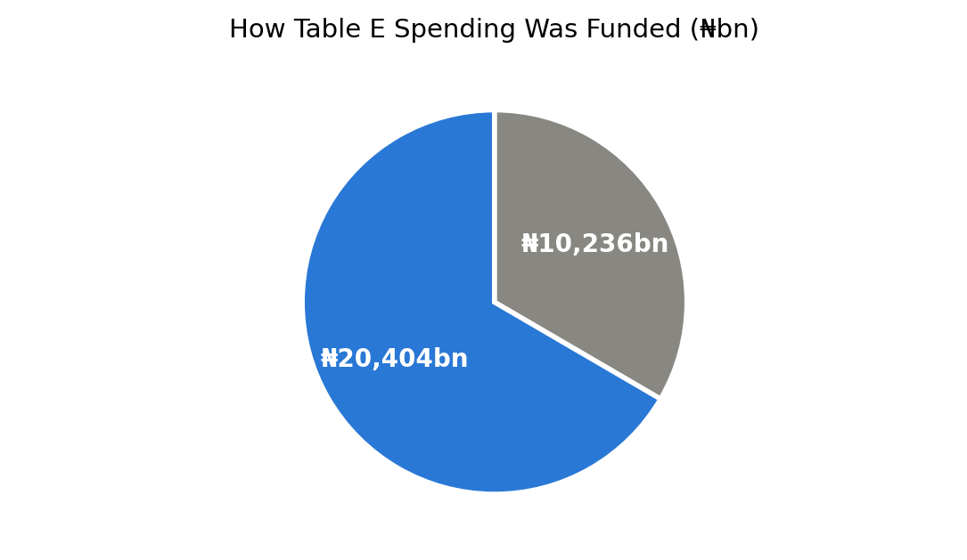
Source | ₦ Billion
Funded by incremental resources (Table D) | 20,404.12
Funded from existing revenue base | 10,236.42
TOTAL | 30,640.54
Two-thirds of the reform-related spending was covered by the incremental resources summarised in Table D; the remainder (₦10,236bn) was absorbed within the existing revenue base.
Appendix 1 — Nigeria Economic Reform Scorecard
Gains, Costs & Harms Prevented
Fiscal sustainability: substantially improved | External stability: substantially improved | Investor confidence: significantly improved, FDI rising | Growth: improving, needs to accelerate | Household welfare: weak, beginning to improve
1. Fiscal Sustainability — fiscal capacity, debt burden, revenue mobilisation & discipline
Indicator | Baseline (May '23) | Current Position | No-Reform '26 Est. | Assessment
Debt Service / Revenue | ~100% (2022) | ~50% (2026 proj.) | 100–200% | 🟢 Major improvement
Tax-to-GDP Ratio | <10% | ~12.5% | ~6% | 🟢 Gains in growth phase
States Unable to Pay Salaries | 27 States (2023) | 0 States (2026) | At least 30 States | 🟢 Bankruptcy prevented
Ways & Means / Monetary Financing | ₦30tn legacy stock | Curtailed | At least ₦60tn and rising | 🟢 Structural improvement
Sovereign Credit Rating (S&P) | B− | B / Stable | CCC risk | 🟢 Upgraded
2. External Stability — external buffers, currency stability, external-sector credibility
Indicator | Baseline (May '23) | Current Position | No-Reform '26 Est. | Assessment
Gross FX Reserves | ~$35bn | $52.5bn (Jul 2026) | $15–25bn | 🟢 Major improvement
Net FX Reserves | ~$3.0bn (2023) | $34.8bn (end-2025) | Near zero / negative | 🟢 Major improvement
Official Exchange Rate | ~₦460/$ | ~₦1,358/$ (Aug 2026) | ₦550–800/$ but unavailable | 🟡 Structural improvement
Official/Parallel FX Premium | ~60%+ | <5% | 150–200%+ | 🟢 Major normalisation
Current Account Balance | $1.21bn surplus (2023) | $14.04bn surplus (2025) | $2bn to $5bn deficit | 🟢 Much stronger balance
3. Investment Climate — financial conditions, investor confidence, capital markets
Indicator | Baseline (May '23) | Current Position | No-Reform '26 Est. | Assessment
Total Capital Importation | $1.13bn (Q1-2023) | $10.37bn (Q1-2026) | $1–3bn/quarter | 🟢 Very strong recovery
FDI | $895m (2022) | $4.01bn (2025) | <$500m | 🟡 Better, growing stronger
Stock Market Capitalisation | ~₦31tn (May-2023) | ~₦150tn (June-2026) | <₦30tn | 🟢 Very strong recovery
Monetary Policy Rate | 18.5% | 26.5% | >35%+ under crisis adj. | 🟡 Cost of stabilisation
Sovereign Eurobond Yield | ~10 to 13% | ~7–8% (mid-2026) | 12–18% / impaired access | 🟢 Improved
4. Social Impact — how macro conditions translate into household welfare
Indicator | Baseline (May '23) | Current Position | No-Reform '26 Est. | Assessment
Headline Inflation | 22.41% | 15.91% (Jun 2026) | 30–50% after disorderly adj. | 🟢 Improving, after early pain
Food Inflation | 24.82% | 17.52% | 35–60% | 🟡 Improving
PMS Price / litre | ~₦185 | ~₦1,100 to ₦1,400 | ~₦185 unavailable, >₦3,000 black market | 🟡 Major cost but worse prevented
Minimum Wage | ₦30,000 | ₦70,000 | ₦30,000–50,000 unpaid | 🟡 Nominal gain; real mixed
Poverty / Household Welfare | High | High; recovery in progress | Severe under crisis scenario | 🟡 WIP, unfinished business
5. Growth & Productivity — scale, pace, and breadth of economic expansion
Indicator | Baseline (May '23) | Current Position | No-Reform '26 Est. | Assessment
Real GDP Growth | 2.31% (Q1-2023) | 3.89% (Q1-2026) | Likely recession, −1–2.5% | 🟢 Improved
Real GDP Per Capita Growth | Negative / contracting | Positive / expanding | −2% to 0% | 🟢 Wrong direction reversed
Non-Oil GDP Growth | <2.0%, weak | ~4.0% (2026 proj.) | 1.0% to −2% | 🟢 Improving
Manufacturing Growth | <1.0%, very weak | 3.29% (Q1-2026) | 0% to −2% | 🟢 Improved
Oil Production | ~1.2–1.4 mbpd | ~1.6–1.75 mbpd | <1.2 mbpd | 🟢 Improved

Appendix 2 — Reform Impact and Call to Action

How the Reform Benefits Ordinary Nigerians
1. Wage increases and timely payment of salaries and pensions
2. Settlement of pension arrears and gratuities owed to retirees
3. Wealth creation for millions of Nigerians through capital market gains
4. Transformative infrastructure development nationwide
5. Top globally friendly student loan scheme (NELFUND) and affordable consumer/SME credit
6. Subsidised mortgage and housing schemes, plus social transfers to the most vulnerable
7. Agricultural interventions strengthening food security
8. Fuel availability and energy security despite global shocks
9. Return of investor confidence, driving local and international investment
10. Tax exemption for low-income earners and small businesses, and a friendlier tax environment for all

Harm the Reforms Prevented
1. Hyperinflation from unchecked printing of the Naira
2. Total collapse of the Naira's value
3. Fuel scarcity and disruption of economic activities
4. Greater poverty across the country
5. Worsening insecurity fuelled by economic crisis
6. Mass business collapse and deeper job losses
7. Corruption in FX allocation and fuel subsidy scheme
8. Bankruptcy of many states and local governments
9. Much higher interest rates
10. Multiplicity of taxes deepening the taxation of poverty

Call to Action
1. Be a Citizen — Support positive government policies. We cannot build our country by opposing every government action.
2. Criticise Constructively — Don't run your country down. Whatever we amplify shapes perception and ultimately our economic reality.
3. Play Your Part — Seek facts and proper understanding, not populist views or sensational headlines.
For more information: visit finance.gov.ng

